Member states of the EU (year of entry)
- 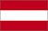Austria (1995)
- 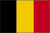Belgium (1952)
- 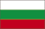Bulgaria (2007)
- 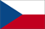Czech Republic (2004)
- 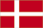Denmark (1973)
- Estonia (2004)
- Finland (1995)
- 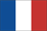France (1952)
- 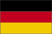Germany (1952)
- Greece (1981)
- 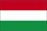Hungary (2004)
- 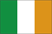Ireland (1973)
- 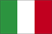Italy (1952)
- Latvia (2004)
- 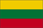Lithuania (2004)
- 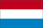Luxembourg (1952)
- 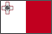Malta (2004)
- 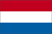Netherlands (1952)
- 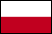Poland (2004)

- 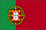Portugal (1986)
- 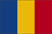Romania (2007)
- 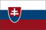Slovakia (2004)
- 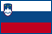Slovenia (2004)
- 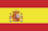Spain (1986)
- 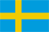Sweden (1995)
- 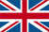United Kingdom (1973)

